SPRING 2019 SEMESTER
MyITLab
- MyITLab can sometimes be having a technical error. Please always reset the question first and then redo. You can check the right steps in MyITLab. I will show you how to do that for MyITLab assignments and exams.

In-class assignments/grading
- If you find out that a student submits a wrong file during grading, please tell them to re-submit the assignment ASAP but you must check that the “Last modified” is no later than the Friday deadline at 11 PM.
- They should not re-submit the assignment via the comments section. They must show you the assignment in class and make sure you check the “Last modified” date. If it is after the deadline, then you MUST not accept it. Please include this in the introductory class and lecture slides.

Missed Exam/Assignments
- They must provide a valid AU excuse to makeup assignments and exams. If a student has an excuse that is not an AU excuse, then he/she must go to the Engineering Student Services on Shelby 1210 to show them their excuse and get a formal one.

Exams/Friday help hours
- If a student is experiencing any difficulty, he/she must first reset the question and you watch to see the students’ actions without any help. Before the exams, you must first attempt the questions to know how they should be answered. Sometimes, the student might know the material, or the book may specify it in a certain way but will not be correct on MyITLab. You can help the student get it right only if you see that the student knows the material but can’t get it right because MyITLab wants it done in a particular way different from the book. OR, there is a technical error.
- No Friday help hours on Friday before break (spring/fall break, thanksgiving break, etc) and week of the break.
- No Friday help hours on the first week of resumption.
- Friday help hours is from 10 AM – 2 PM (NOT 3 PM).

UTAs
- Be punctual to class.
- Always face the class; do not back the students. If you are doing an urgent work on your laptop, you have to carry it on your laps and raise your head up very often to check if students need your help. This is very important.

Remember:
- Publish your sections and upload lectures before class.
- Send class emails before your first class, to remind them of their exams and other important issues.
- Student and Instructor contract quiz must be done on the first day of class after introduction.

A screenshot of the course policy from PCA website:
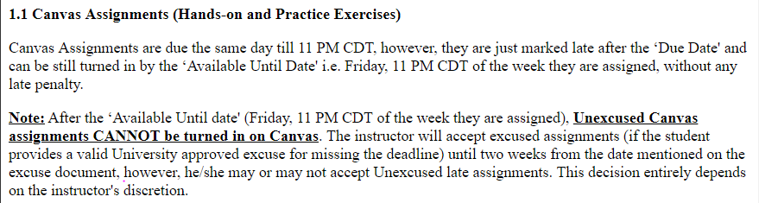

The only time an instructor may accept an unexcused work is if it has been initially attempted but the wrong file or inaccessible file was submitted. In both cases, the “Date Modified” must be checked and it must not be after the Friday deadline i.e. Friday of the week the classwork was assigned.

